- Area of part of a circle

1. The figure below shows a circle of radius 9cm and centre O. Chord AB is 7cm long. Calculate the area of the shaded region. (4mks)
O
9cm

O
A
B

2. The figure below shows two intersecting circles with centres P and Q of radius 8cm and 10cm respectively. Length AB = 12cm
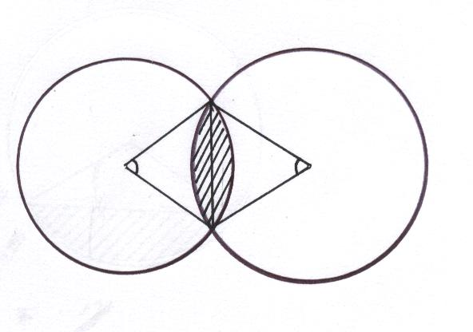
ß
A
B
Q
P
ө
Calculate:
a) 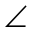 APB (2mks)
b) AQB (2mks)
c) Area of the shaded region (6mks)
3.
O
A
B
5cm
5cm

The diagram above represents a circle centre o of radius 5cm. The minor arc AB subtends an angle of 120⁰ at the centre. Find the area of the shaded part. (3mks)

4. The figure below shows a regular pentagon inscribed in a circle of radius 12cm, centre O.
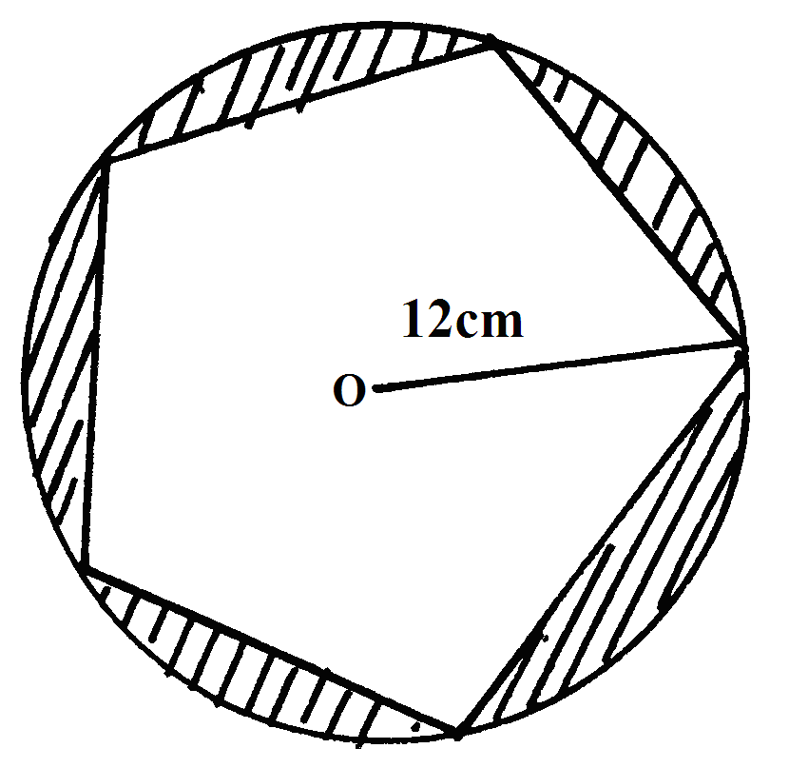
Calculate the area of the shaded part. (3mks)
5. Two circles of radii 13cm and 16cm intersect such that they share a common chord of length 20cm. calculate the area of the shaded part. 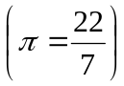 (10mks)
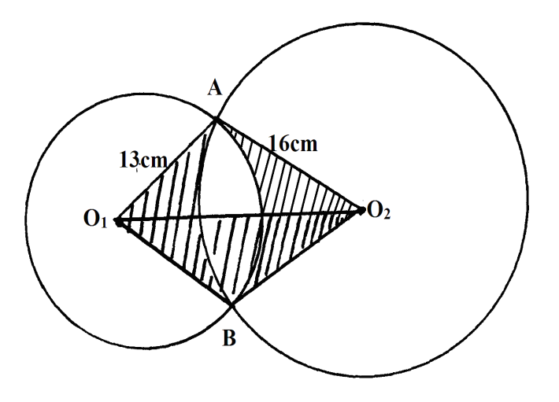
6. Find the perimeter of the figure below, given AB,BC and AC are diameters. (4mks)

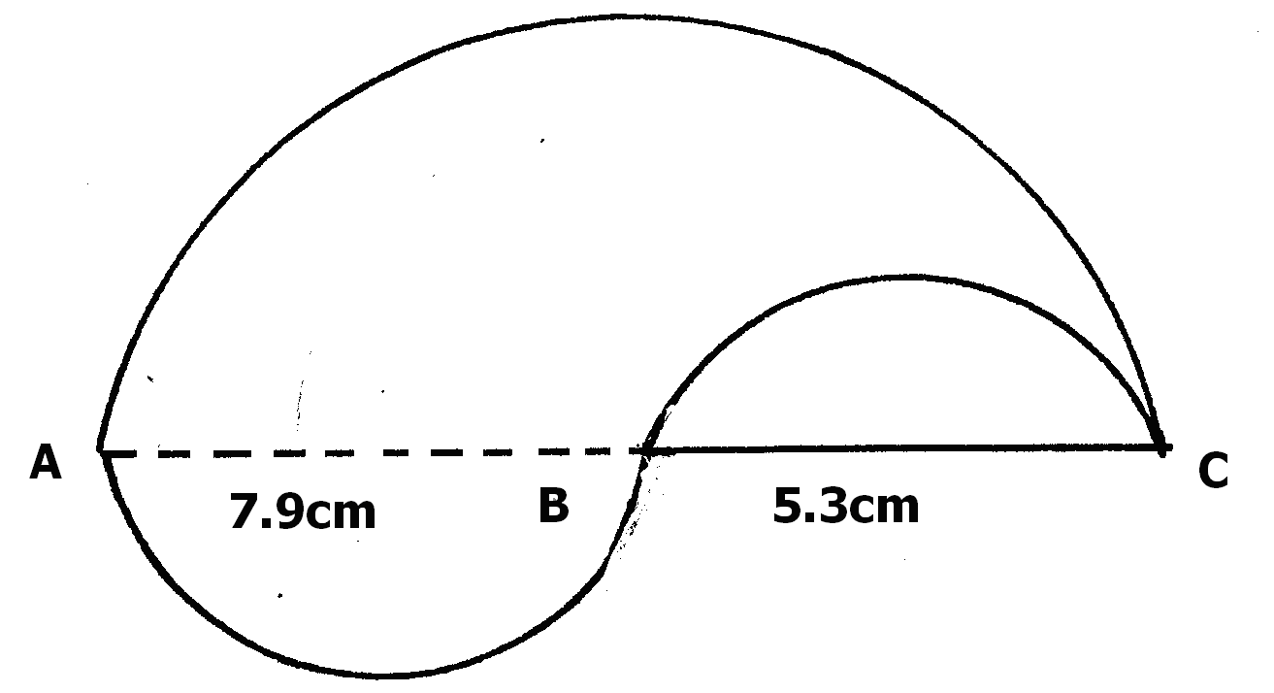

7. The figure below shows two intersecting circles. The radius of a circle A is 12cm and that of circle B is 8 cm.

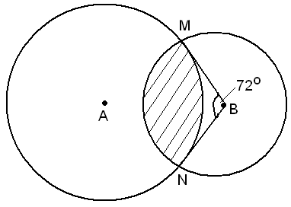

If the angle MBN = 72º, calculate
- The size of the angle MAN
b) The length of MN
c) The area of the shaded region.
8.
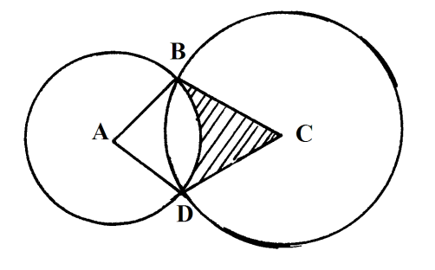
In the diagram above, two circles, centres A and C and radii 7cm and 24cm respectively intersect at B and D. AC = 25cm.
a) Show that angel ABC = 90⁰
b) Calculate
i) the size of obtuse angel BAD
ii) the area of the shaded part (10 Mks)
9. The ends of the roof of a workshop are segments of a circle of radius 10m. The roof is
20m long. The angle at the centre of the circle is 120º as shown in the figure below:
120º
10cm

(a) Calculate :-
(i) The area of one end of the roof
(ii) The area of the curved surface of the roof
(b) What would be the cost to the nearest shilling of covering the two ends and the curved surface
with galvanized iron sheets costing shs.310 per square metre

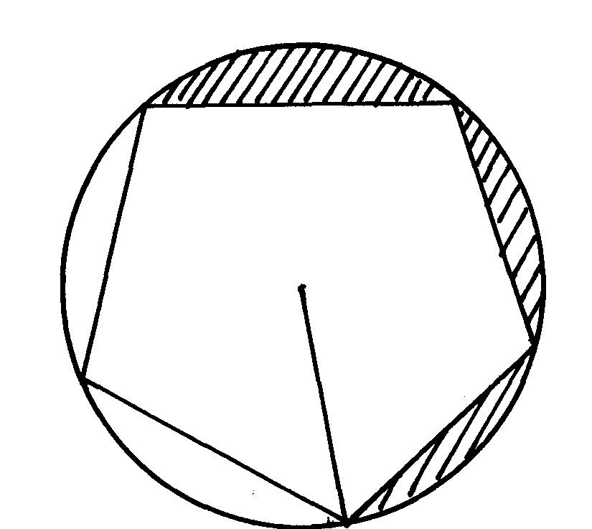
10. The diagram below, not drawn to scale, is a regular pengtagon circumscribed in a circle
of radius 10cm at centre O

O
●
Find;
(a) The side of the pentagon
10cm
(b) The area of the shaded region

11. Triangle PQR is inscribed in he circle PQ= 7.8cm, PR = 6.6cm and QR = 5.9cm. Find:

R
Q
P
7.8cm
6.6cm
5.9cm

(a) The radius of the circle, correct to one decimal place
(b) The angles of the triangle
(c) The area of shaded region

12. The figure below represents sector OAC and OBD with radius OA and OB respectively.
Given that OB is twice OA and angle AOC = 60º. Calculate the area of the shaded region
B
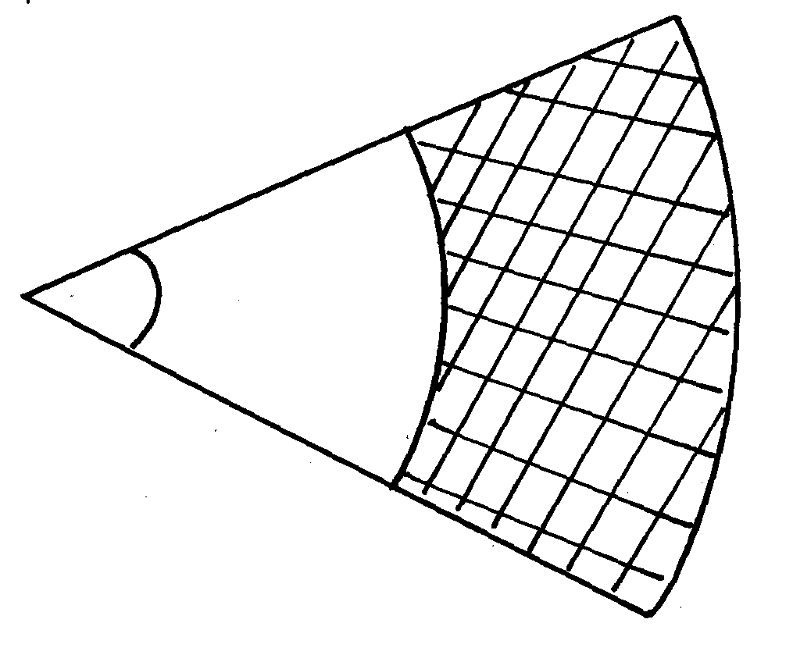
in m², given that OA = 12cm
A

60º
O

C

